About the Jernigan Family
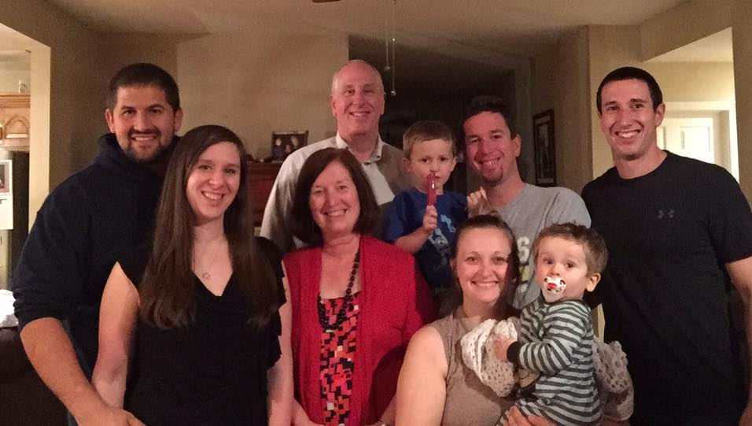

Dr. James Robert “Robby” Jernigan
Education: Graduated from Kendrick High School (1972) in Columbus, Georgia; B.S. in Accounting/Business Administration from Auburn University (1977), Auburn, Alabama; attended Southeastern University of the Assemblies of God (1978-79) in Lakeland, Florida; M.A. in Biblical Studies from Assemblies of God Theological Seminary (1981); Doctor of Ministry degree from Assemblies of God Theological Seminary at Evangel University in 2018.
Training: Lifeguard & Water Safety Instructor, Search & Rescue Pilot/Flight Instructor, Firefighter I & II certified, Fire Service Instructor II; Emergency Medical Technician – Basic (National Registry), Haz-Mat Operations, MVC Extrication, Emergency Vehicle Driver/Operator & Lead Instructor, American Heart Association CPR Instructor; Missouri EMS Instructor.
Positions: Ordained minister with the Assemblies of God since 1983. Former USAF/Civil Air Patrol Chaplain for 10 years, Former Police Chaplain (Springfield MO Police Dept) for 3 years, current Fire Chaplain (Marshfield, MO) for 15+ years. Trained Death Scene Investigator for the Webster County Coroner’s Office since 2012. Nationally-appointed U. S. Missionary with the Assemblies of God beginning in 1983.

Elizabeth “Betty” (Jeter) Jernigan
Early Years: Until age 5, lived in Spain and North Africa as the daughter of renowned missionary/author Hugh & Gertrude Jeter. Her brothers are Stan (Christian TV producer in Virginia Beach, VA), Robert (Flight Instructor for American Airlines), Don and Doug (twins and both foreign missionaries with the Assemblies of God). Hugh taught missions for decades at Southwestern A/G University in Waxahachie, Texas, and Southern Arizona Bible College, Hereford, Arizona.
Education: Graduated from Waxahachie High School (1970) in Texas; B.A. in Missions from Southwestern A/G University (1974), diploma in Hispanic Studies from University of Barcelona, Spain (1975), M.A. in Inter-cultural Ministry from Assemblies of God Theological Seminary (1981).
Positions: Former missionary to Spain, former Chi Alpha Campus Ministries Director for North Texas District A/G, specialized license minister with the Assemblies of God, nationally appointed U. S. Missionary beginning in 1983.
Author: In 2020, Betty’s first book was published by Mount Crest Books. Her book entitled Jeter Women is an historical novel which portrays five of Betty’s ancestors and their courageous faith in Gospel missions. It has wide-spread appeal and has been well-received by many.

Their Family
J. Matthew Jernigan (son): Homeschooled through 8th grade. Valedictorian of Marshfield High School's class of 2002. Attended Southwestern Assemblies of God University in Waxahachie, Texas and graduated with honors from College of the Ozarks near Branson, Missouri in 2006. Played soccer and baseball in college. Is an avid golfer. Graduated from Southwest Baptist University with a master’s degree in Education. Currently, a teacher and coach in Lebanon, Missouri. He is also providing ministry to junior high school youth at a local church in Lebanon. Married to Kyleigh (Savas) Jernigan. They have two boys, Brock and Jett.
Jamie Jernigan-Christ (daughter): Homeschooled through 12th grade. Attended Marshfield High School where she took dual credit college classes. Graduated from College of the Ozarks with a double major in Accounting and Computer Information Science in 2011. She works as a senior software engineer for a company based in Kansas City, Missouri. She works out of her home and is married to Aaron Christ of Branson, Missouri. She volunteers her time in ministry to children at her local church. They have two children, Ender and Kayleigh.
Dr. Ethan J. Jernigan, D.O. (son): Homeschooled through 8th grade. Honors graduate from Marshfield High School (2009). Multi-sport athlete in high school. Graduated from Missouri State University in 2013 with a bachelor’s degree in Cell & Molecular Biology. Graduated from A.T. Still College of Osteopathic Medicine in Kirksville, Missouri in 2020. Currently completing his first-year medical residency as an Emergency Department Physician in Lawton, Oklahoma.

